07th March 2017

**YOKOHAMA Announces Return of “YOKOHAMA A008P”**

YOKOHAMA announced today that at the March 7 press conference kicking off the 87th Geneva Motor Show it formally announced the return of the “YOKOHAMA A008P,” one of the Company’s landmark tyres. The new YOKOHAMA A008P will be available in two sizes – 205/55ZR16 91W for front tyres and 245/45ZR16 94W for rear tyres. Sales in Europe are scheduled to begin in autumn 2017 with other regions to be considered.   
  
The original “YOKOHAMA A008P” was unveiled in 1989. After receiving Porsche’s technical certification, the tyre was installed as original equipment on the Porsche 911 type 964. The “YOKOHAMA A008P” paved the way for Porsche’s steady use of YOKOHAMA brand tyres, including today’s flagship tyre, the “ADVAN Sport V105”. The “YOKOHAMA A008P” thus contributed to the spread of the YOKOHAMA brand name around the world, making it one of the Company’s historically important products.   
  
A prototype of the new YOKOHAMA A008P is on display at the YOKOHAMA booth at the 87th Geneva Motor Show,* which runs from Tuesday March 7 until Sunday March 19 in Geneva, Switzerland. The booth features the new YOKOHAMA A008P on a 1989 Porsche 911 930 Turbo Cabriolet, made available by Porsche from its museum of classic Porsche models.  
  
* 87th Geneva Motor Show schedule: press days on March 7–8 (Tue–Wed); open to the general public March 9 (Thu) to March 19 (Sun).

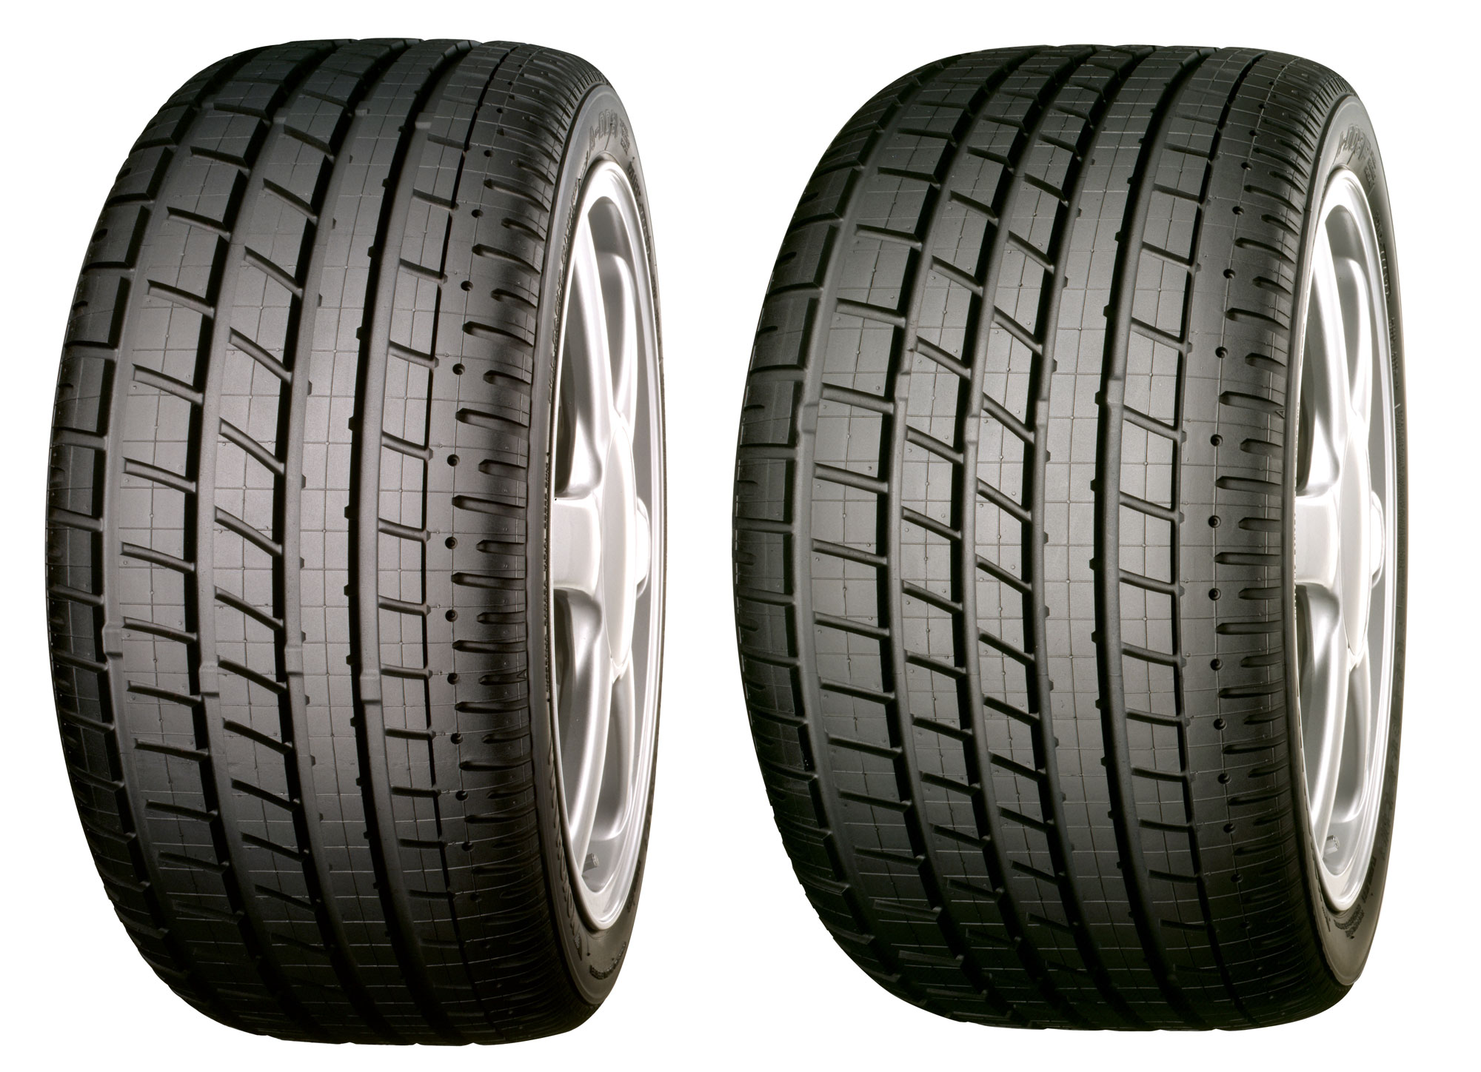

*YOKOHAMA A008P*